Overview

For AMI meter being billed over the air, the interval KWH reads data will be stored in the MDM system. Interval meter reads stored in MDM system can be viewed in SAP by using transaction code EEDM02.

Business Process Procedure Overview
Overview of Process to be followed
- Display profile value screen using transaction EEDM02
- Provide selection parameters
- Display interval values

Procedural Steps

Display the profile values screen

(Transaction Code can be displayed by selecting System -> Status)
EEDM02

Execute transaction EEDM02 to get to the Display profile values initial screen.

The following screen will be displayed.

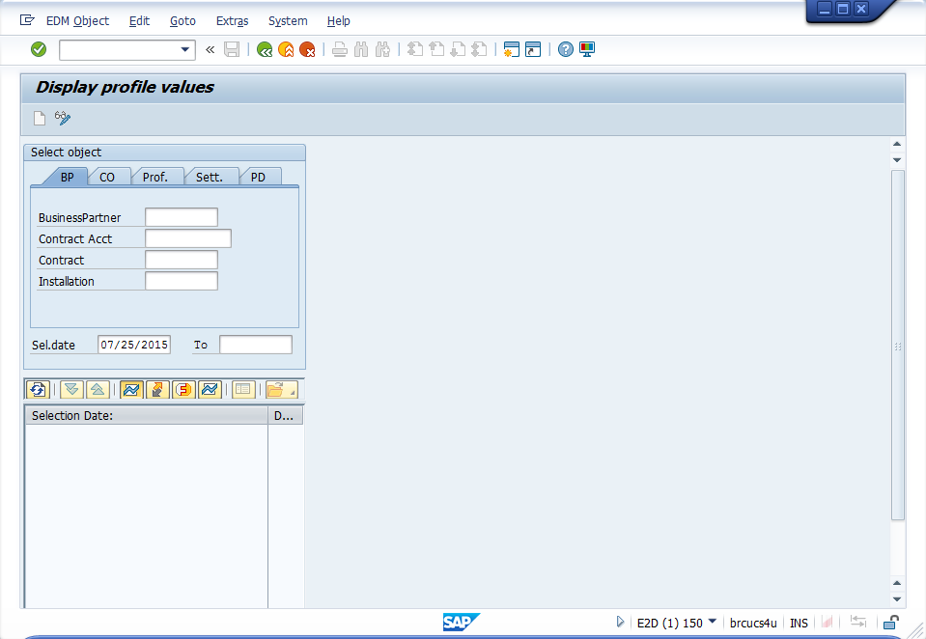

Provide the selection parameters

Enter the Installation number and the data range. When you click on execute, the master data tree will be displayed.

For this example, the installation was used as a selection parameter. You can also use other parameters like Contract, Contract Account, Business Partner, etc.

The following screen will be displayed.

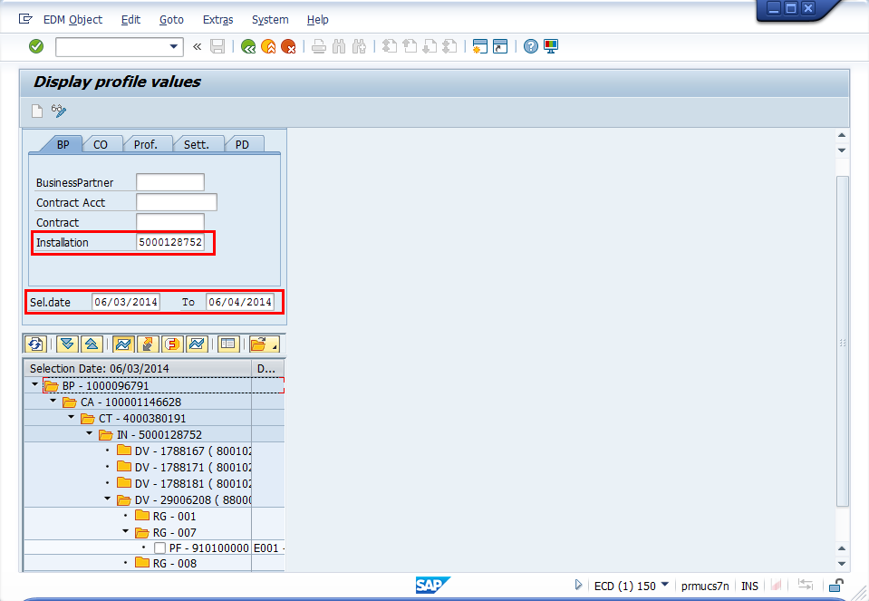

Display the profile values

Click on the profile to display the interval reads.

Interval reads with green status are actual reads.

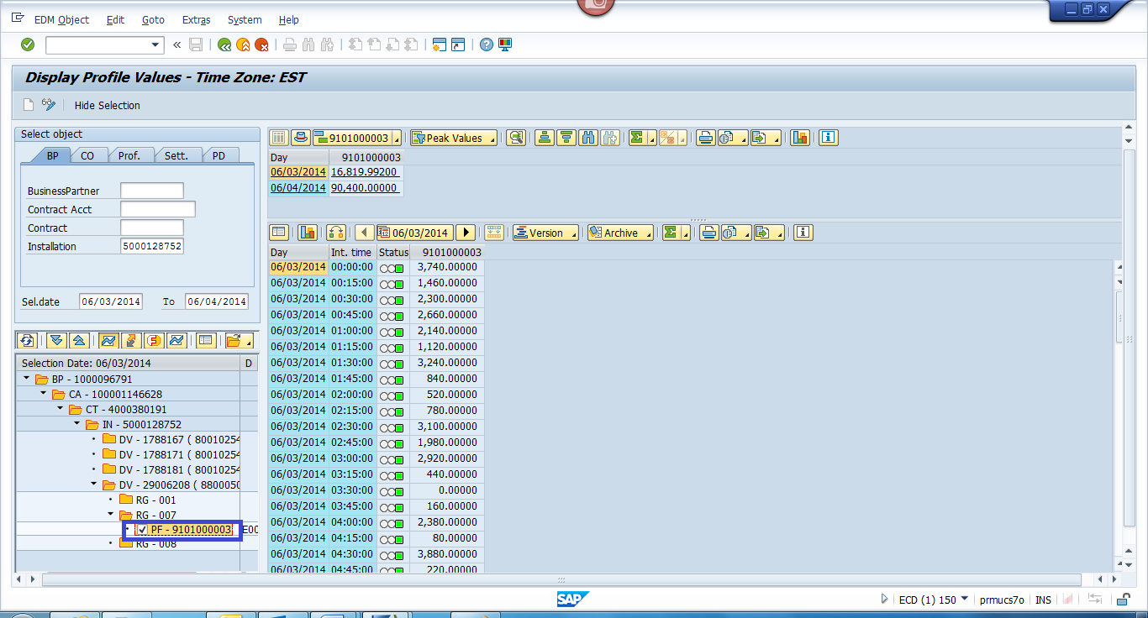

Interval reads with yellow status are reads that has been estimated by the MDM system.

